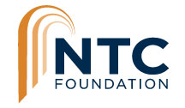

FOR IMMEDIATE RELEASE
MEDIA CONTACT:
Madeleine Hennessy
Olive Creative Strategies, Inc.
619.541.8254
madeleine@olivecreativestrategies.com

NTC Foundation announces dedication of Dorothea Laub Music & Arts Center
Philanthropic support maintains ARTS DISTRICT Liberty Station programming to benefit tenants and community
San Diego, CA (August 26, 2020) –NTC Foundation (NTCF) is honored to announce the dedication of Building 176 thanks to a Legacy Naming Gift from long-time ARTS DISTRICT Liberty Station patron, Dorothea Laub. The Foundation is also pleased to announce an additional $143,000 in grants and civic support received this year from Bank of Southern California, California Arts Council, City of San Diego Commission for Arts & Culture, Community Service Association of SDUSD, Pratt Memorial Fund, ResMed Foundation, and The Samuel I. & John Henry Fox Foundation.
Through civic and philanthropic support, the NTC Foundation is continuing innovative marketing, promotional and educational programs that benefit ARTS DISTRICT tenants and the community, support our tenants during the current economic challenges, and keep the NTCF well-positioned to take advantage of new opportunities in the future as the community safely returns to the ARTS DISTRICT.
“Gifts like this are an extraordinary show of support for this landmark cultural project, especially during these challenging times,” said Lisa Johnson, NTC Foundation President & CEO. “We couldn’t be more grateful and honored by Dottie’s and others belief in our work to preserve and develop our community to benefit generations to come.”
Building 176 will be renamed to Dorothea Laub Music & Arts Center after the receipt of a $1 million legacy naming gift from Dorothea Laub through the Laub Family Trust in early 2020. The building, prominently located at the main entrance to Liberty Station at Rosecrans Street and Roosevelt Road, is 21,179 square feet and is home to the San Diego Craft Collective, National Comedy Theatre, White Box Live Arts, California Ballet School, Monart School of Art, Young Lion’s Jazz Conservatory and If I Was A Bird Yoga Studio. Built in 1942 for classrooms to train Navy recruits, it was renovated by NTCF at a cost of more than $5.2 million in 2007.
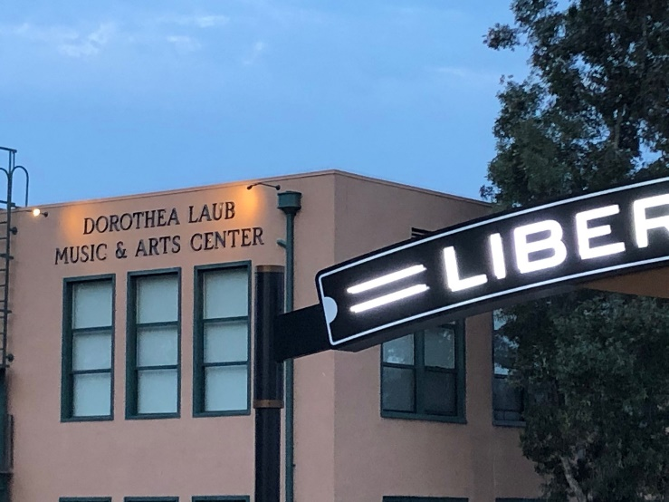

“I’m happy to continue to contribute to the growth of this local treasure and help set an example of the kind of support that can be provided and is needed to sustain a vibrant Arts District of this caliber for San Diego,” said Dottie Laub.
This is the fourth building naming gift received by the NTC Foundation since it was founded in 2000, including two gifts from the Laub Family Trust to dedicate the Dick Laub NTC Command Center and the Dorothea Laub Dance Place, and a naming gift from the Corky McMillin family to dedicate the Corky McMillin Companies Event Center, in honor of the company’s employees. The NTCF’s mission is to renovate and operate 26 historic buildings at the former Naval Training Center, to create a vibrant ARTS DISTRICT focused on experiencing the arts, culture and creativity that are the hallmark of the San Diego region.
To date, the NTC Foundation has overseen the renovations of 17 of 26 historic Navy buildings under its stewardship. Planning and design work is underway for 5 of the remaining 9 buildings, including a Performing Arts Center in Building 178.
The NTC Foundation has Legacy Naming opportunities remaining at the ARTS DISTRICT. Contact Executive Director Alan Ziter at 619 573-9315 to learn more.
# # #

About NTC Foundation
NTC Foundation was established in 2000 as a 501(c)(3) nonprofit to enrich the lives of San Diegans by renovating this signature community asset and creating, facilitating, and operating ARTS DISTRICT as a100-acre creative district. Visitors experience the arts, culture, creativity, and cuisine that are the hallmarks of the San Diego region and enjoy innovative experiences in a historic setting at Liberty Station that inspire lives for generations to come. www.ntcfoundation.org

About ARTS DISTRICT Liberty Station
ARTS DISTRICT Liberty Station is San Diego’s largest Arts & Cultural District located in historic buildings at the former Naval Training Center in the Liberty Station neighborhood, near Downtown on San Diego Bay. With 100 park-like acres, the ARTS DISTRICT is home to nearly 145 museums and galleries, artist studios, dance companies, fine dining, creative retail and other organizations that showcase San Diego’s creative community and provide innovative experiences for the public. www.artsdistrictlibertystation.com

