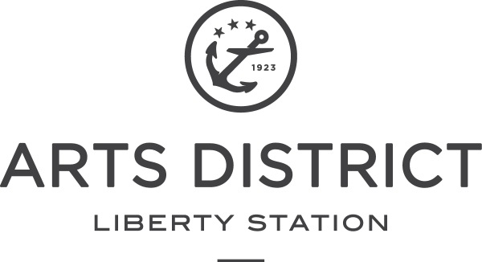
FACT SHEET
HISTORY IN THE MAKING | A NAVAL BASE-TURNED-NEIGHBORHOOD
- Dedicated: October 27, 1923
- Liberty Station was the first permanent Naval Training Center on the West Coast
- Operating Dates: 1923 – 1997
- City of San Diego Ownership: 1997 - 2000
- The Corky McMillin Companies Master Developer: 2000 – present
- Liberty Station’s Non-Profit NTC Foundation founded in: 2000
- ARTS DISTRICT first building open: 2006
- 2017 marked the 10th Anniversary Year celebrating of the opening of ARTS DISTRICT Liberty Station (formerly NTC Promenade)
ABOUT LIBERTY STATION
Located in San Diego, Calif., Liberty Station was built upon naval roots and was originally the Naval Training Center (NTC) that opened in 1923. NTC transitioned into Liberty Station and became a cultural hub of art, leisure and history—creating a timeless destination. Today, Liberty Station is San Diego’s signature neighborhood, inviting residents, the community and visitors to connect through events and experiences while discovering and exploring all of Liberty Station’s offerings. The neighborhood features an array of boutiques and shops, over 70 local galleries in the ARTS DISTRICT, and dozens of delectable dining spots. Built by design, Liberty Station creates an authentic experience—encompassing beautifully landscaped promenades, restored historic buildings that have been preserved for today’s commerce, storied corridors, historic landmarks, and spacious plazas. The historic San Diego destination is managed by the Liberty Station Community Association (LSCA), which works to maintain, beautify, promote, and develop the neighborhood.
HISTORY IN THE DETAILS | REVIVAL-STYLE ARCHITECTURE
- Liberty Station’s 1920s architecture was inspired heavily by the Spanish Colonial Revival-style that dominated the era.
- Originally built in 1923 from designs by architect Lincoln Rogers, who was influenced by Bertram G. Goodhue’s designs for the 1915 Panama Exhibition in Balboa Park, with original landscaping designed by the park’s superintendent of the time.
- 52 buildings designated as a Historic District on the National Register of Historic Places.

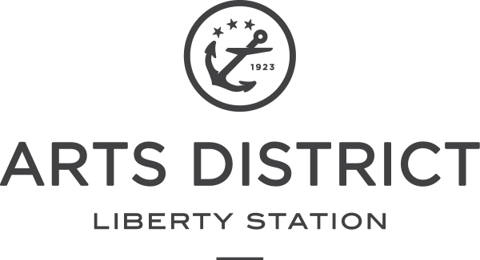
SOMETHING FOR EVERYONE | DISTRICTS WITHIN THE NEIGHBORHOOD
ARTS DISTRICT Liberty Station: A burgeoning hub for life and culture in San Diego, ARTS DISTRICT Liberty Station is a unique destination filled with nearly 120 galleries, museums, artists, studios, makers, creators and distinctive dining experiences.
ARTS DISTRICT Liberty Station is a destination where visitors can stroll the 100 park-like acres, discover something new each time and collect beautiful moments. Many of the 38 historic buildings are now bursting with authenticity, creativity, heritage and innovation. Always changing and evolving, ARTS DISTRICT is a place to create, connect, learn, shop, dine, meet, explore and buy local art.
From artists and dancers to boutique shops, a historic golf course, seasonal holiday ice rink, an array of community event venues, luxury cinemas, local restaurants and a public market, the ARTS DISTRICT abounds with entertainment, annual festivals and innovative cultural and culinary experiences. The free Friday Night Liberty gallery walk is a monthly signature event.
Moniker Events at Liberty Station, located within the ARTS DISTRICT, offers 6 distinctive indoor and outdoor venues for events, celebrations and more for public and private events.

THE QUARTER: Centrally located in Liberty Station, The Quarter aims to serve the daily needs of the surrounding Point Loma community. Fostering a place for connectivity and usability, The Quarter houses a selection of eateries, grocers, banks, as well as a chapel, various medical practices and office spaces. Surrounding neighborhoods utilize The Quarter as a convenient one-stop-shop for daily errands, with Vons, Trader Joes, the Postal Annex and a dry cleaners located along Truxtun Road.
THE NEIGHBORHOOD: Broken into two main sections, the residential district of Liberty Station comprises both military and a civilian community, which includes townhomes alongside single family dwellings. There are 350 homes spread across 37acres. Nearby this area, a 22-acre educational district consists of four individual public charter schools collectively known as High Tech Village. It is also home to The Rock Church.
SOUTH POINT: Conveniently located near the San Diego International Airport, South Point offers travelers an array of budget-friendly hotel accommodations. With easy freeway access and walkability to Liberty Station, the district offers travelers the chance to relax, explore and discover without ever missing a beat. Existing hotels include the Courtyard Marriott and Homewood Suites by Hilton, with three additional hotels slated for completion in late 2020.
BY THE NUMBERS
Space:
- Liberty Station Total Acreage: 361
- ARTS DISTRICT Total Acreage: 100
- Total Parkland Acres: 48
- Total Number of ARTS DISTRICT Buildings: 45

Business Breakdown:
- Shopping & Retail: 24
- Restaurant & Dining: 30
- Galleries & Artist Studios: 57
- Health & Fitness: 16
- Hotels: 2
- Event Spaces: 11

HOTEL & ACCOMMODATION
- Courtyard by Marriot | 2592 Laning Road, San Diego, CA 92106
- Homewood Suites by Hilton |2576 Laning Road, San Diego, CA 92106
- Hampton Inn & Suites | 2211 Lee Court, San Diego, CA 92101
- TownPlace Suites by Marriott | 2311 Lee Court, San Diego, CA 92101
AWARDS & ACCOLADES
- Prix d’Excellence Award by the International Real Estate Federation, 2011
- Orchid Award, Architectural Landscape at NTC Promenade, San Diego Architectural Foundation, 2007
- Redevelopment Award of Merit for Liberty Marketplace from California Construction Magazine
- Friday Night Liberty named “Best Free Arts Event” by San Diego Magazine, 2015
- Named “Dining District of the Year” by the San Diego Union Tribune, 2015
- Named “Next Hot Neighborhood” by San Diego Magazine, 2016
- Healthy Places Award for the ARTS DISTRICT by ULI San Diego-Tijuana, 2016 Orchid Award, Liberty Public Market, San Diego Architectural Foundation, 2016
- Orchid Award, ARTS DISTRICT, Adaptive Re-Use, SD Architectural Foundation, 2017

ABOUT THE CORKY MCMILLIN COMPANIES
Started in 1960 as a remodeling and custom-home builder, The Corky McMillin Companies, has grown into a fully integrated real estate investment, mixed use, land development and home-building company. The Corky McMillin Companies now operates in the California regional markets of San Diego and Temecula. McMillin strongly believes the success of a community is defined by the people and organizations that support it. Employees and associates of The Corky McMillin Companies contribute time and resources to various charitable endeavors. Recently, The Corky McMillin Companies was honored by the San Diego City Council for its contribution to civic, arts and educational projects throughout the city. January 19, 1999 was named McMillin Companies Day in San Diego. In 2001, the Chula Vista Elementary School District named its newest school Corky McMillin Elementary School. The most recent award was given to The Corky McMillin Companies by the San Diego Business Journal and University of San Diego's Family Business Forum. The organization was given the Large Family-Owned Business Award for its family-first attitude, a basis of the company’s success for more than 40 years. For more information, visit www.mcmillin.com.
“At its core, Liberty Station is more than just a neighborhood. It’s a unique collective of artisans, makers, and foodies that inspire its visitors to dive deeper into the everyday. Through a thoughtfully curated combination of dining, entertainment and cultural experiences, we aim to build a greater sense of place for our local community—welcoming our guests to slow down, connect, and create lasting memories within the neighborhood.” - Andy McMillin, Principal of McMillin
ABOUT NTC FOUNDATION
The NTC Foundation was established in 2000 as a 501(c)3 nonprofit foundation to enrich the lives of San Diegans by renovating 26 historic buildings at the former Naval Training Center to create, facilitate and operate a broad-based complex focused on experiencing the arts, culture, and creativity that are the hallmark of the San Diego region. For more information, visit www.ntcfoundation.org
“The successful transformation of Naval Training Center to Arts District has created a burgeoning destination focusing on arts, culture and creativity. As we approach our 10 year anniversary, we are positioned for even more growth and greater prominence. The NTC Foundation is committed to continuing to develop the ARTS DISTRICT with a focus on authenticity, heritage and innovative experiences.”
- Lisa Johnson, President and CEO, NTC Foundation
More information and helpful links
Liberty Station Links:
www.LibertyStation.com
Instagram: @libertystation
Twitter: @Liberty_Station
Facebook: @LibertyStation
ARTS DISTRICT Liberty Station Links
www.ArtsDistrictLibertyStation.com
Instagram: @ArtsDistrictLibertyStation
Facebook: www.facebook.com/ArtsDistrictLibertyStation
Twitter: @ArtsDistrictLS
Media Inquiries
Olive Creative Strategies
Parisa Bukhowa 619.955.5285 ext. 107 parisa@olivecreativestrategies.com

